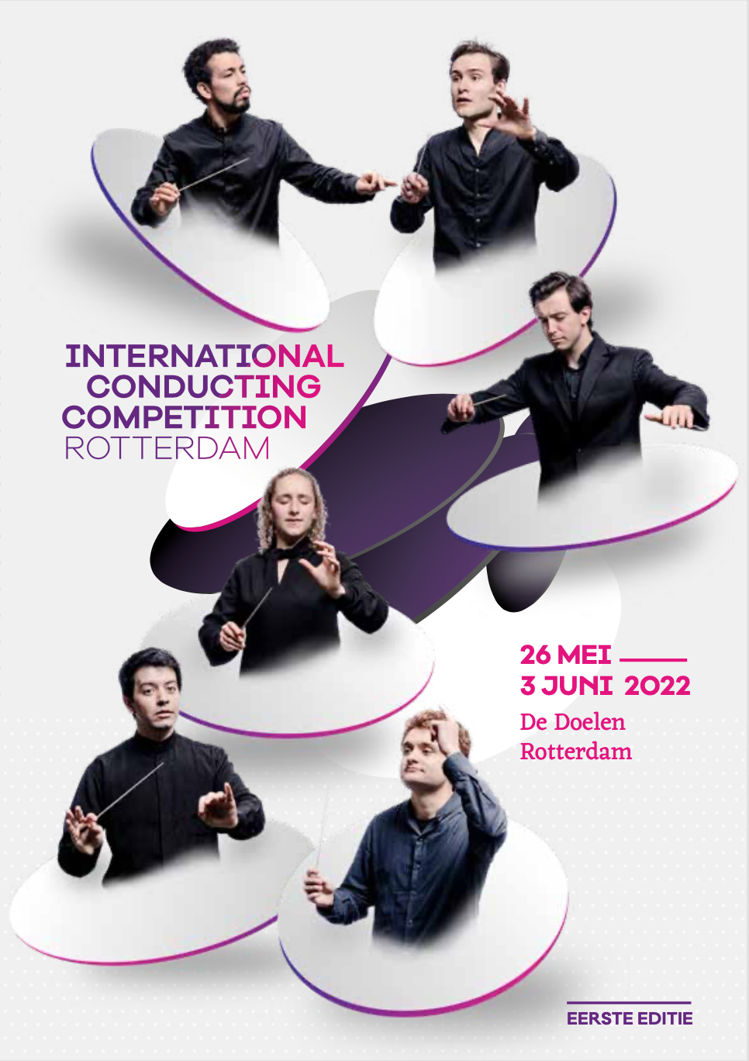

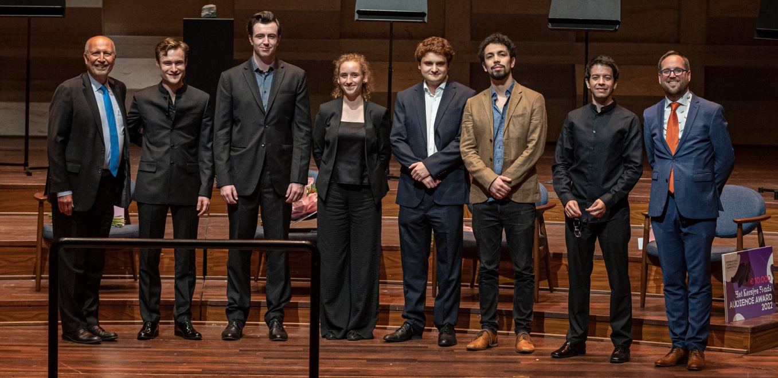

Quotes participants:
- Bertie: “It has always been clear that ICCR puts the interests of us musicians and the music first. I speak on behalf of all six when I say we’ve all felt so supported through the whole process, and you made this very complicated event look like an easy thing to pull off!“
- Chloe: “ICCR really feels like a complete masters degree programme in a pressure cooking.”
- Luis: ”ICCR is absolutely incredible. It has provided me with more serious stage-time than I have had throughout my education.”
- Carlos: “This has been by far the best thing that ever happened to me. I am not only grateful for the opportunities ICCR has provided, but especially for all the amazing people that I have met and with whom I hope to build long term relations.”
- Joel: “Having done my fair share of competitions, I have never had such a positive experience in working with the ensembles, their artistic level and musicianship is truly unparalleled.”

Career development 2021-22
For the participants an intensive coaching has taken place between the selection round (in May 2021) and the competition in 2022, and included two Academy weeks as well as online sessions.

Academy week 1 (11-14 October 2021)
- Meetings with Rotterdams Philharmonic, Orchestra of 18th Century and DoelenEnsemble.
- Radiotraining by Hans Haffmans at the studio of Radio 4.
- Workshop with composer Joey Roukens.
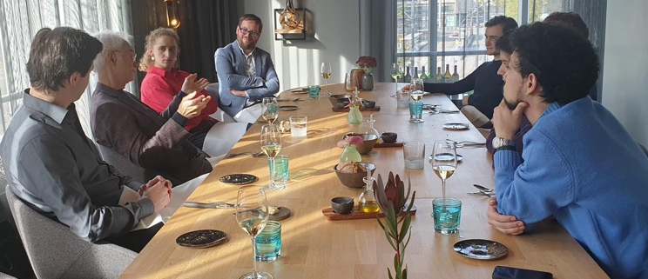
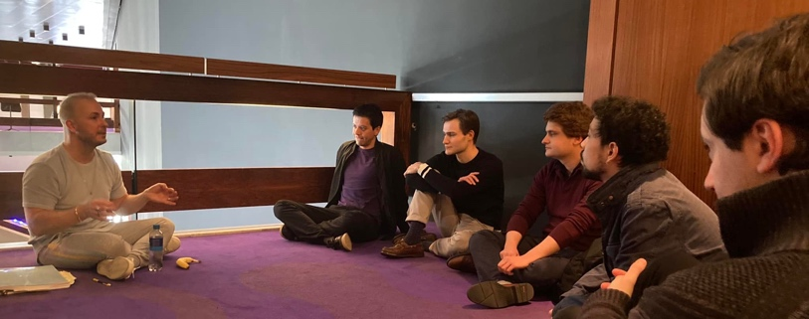
- Masterclasses with John Adams, Kenneth Montgomery and Roberta Alexander.

Academy week 2 (22-25 April 2022)
- Masterclass met Yannick Nézet-Seguin / Rotterdam Philharmonic
- Workshop met George Wiegel.
- Meeting with Concertgebouw Orchestra / conductor Iván Fischer and management Dominik Winterling and Ulrike Niehoff.
- Meeting with Radio Philharmonisch Orchestra / conductor Karina Canellakis and management Roland Kieft en Janneke Godschalk.
- Meeting with National Opera / NedPho / conductor Lorenzo Viotti en Sophie de Lint.
- Meeting with Residence Orchestra / conductor Anja Bihlmaier and management Sven Arne Tepl.
- Workshop with Martijn Sanders.
- Pubic speaking worksshop by Christiaan Kuyvenhoven.

Other activities:
- Fotoshoots.
- Restyle of personal website.
- Branding traject with Green Room Creatives. Each conductor worked 1-on-1 during 8 workshops to discover their personal story, and interpret it for a narrative in their communication.
- Professional coaching by Aimee Paret during 6 indiviual sessions.
- Interview training by journalist Laurence Vittes.

Documentary:
Each conductor had the opportunity to work with movie-maker Nander Cirkel to create a personal documentary:
- Carlos Ágreda shows viewers around in his hometown Bogota, where he performs with the National Orchestra and Chorus.
- Bertie Baigent showcases his own opera festival Waterperry, as well as at his home in London.
- Martijn Dendievel was filmed in Gent around his project with Symfonieorkest van Vlaanderen, in his home town of Brugge, at the beach of Knokke and at his current residence in Weimar, Germany.
- Chloe Rooke was followed as she toured London with her Street Orchestra Live, as well as during rehearsals with the Residence Orchestra in The Hague and at the beach of Scheveningen, where she currently lives.
- Joel Sandelson was filmed around his debut at the Salzburger Festspiele, as well as in London.
- Luis Toro Araya was also filmed at the Salzburger Festspiele, as well as in his hometown of Zürich around a Mahler production.

Competition2022

Proms ronde (24-25-26 May)
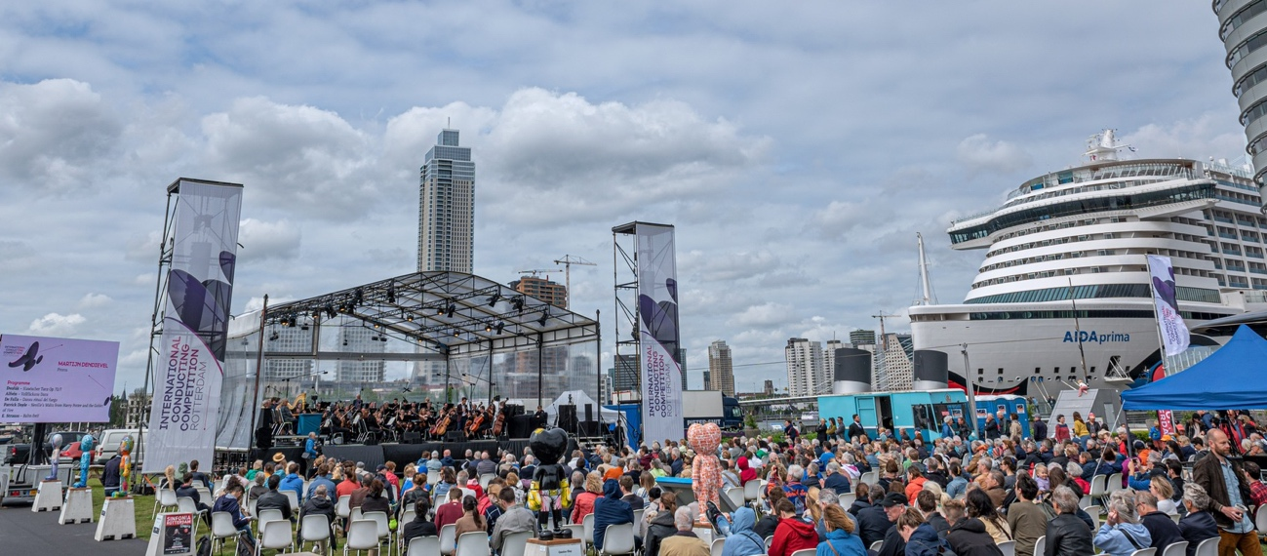
Sinfonia Rotterdam
Jury: Marieke Blankestijn, Ara Guzelimian (chair), Wayne Marshall, Ed Spanjaard, Elmar Weingarten, Joshua Weilerstein and John Wilson.
Repertoire: free choice by the conductors.

Winner: Martijn Dendievel

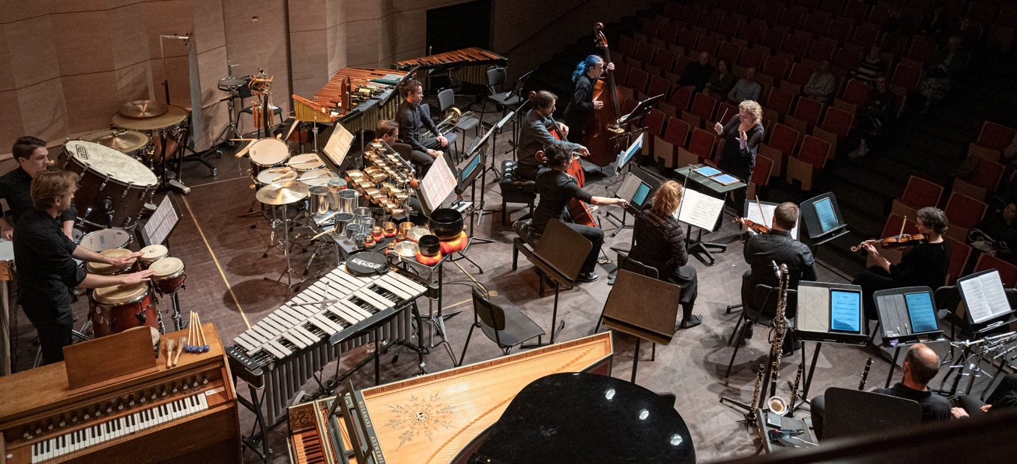
Contemporary round (27-28 May)
Doelenensemble
Jury: Michel van der Aa, Ara Guzelimian (chair), James MacMillan, Franck Ollu, Ed Spanjaard, Anna Thorvaldsdottir and Elmar Weingarten.
Repertoire: Schoenberg, Chin and Ligeti

Winner: Chloe Rooke

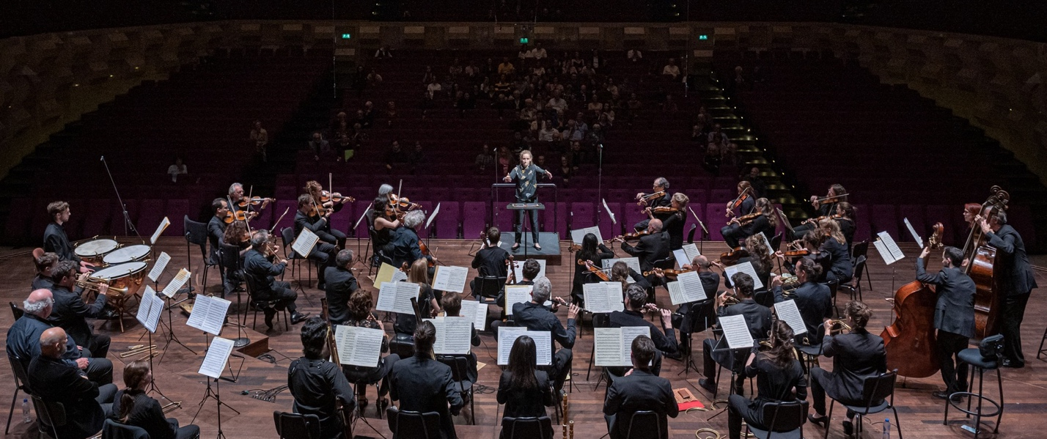
Classical Round (27, 29, 30 May)
Orchestra of Eightteenth Century
Jury: Michael Garvey, Jane Glover, Ara Guzelimian (chair), Kenneth Montgomery, Ton Koopman, Ed Spanjaard en Elmar Weingarten.
Repertoire: Haydn, Beethoven en Schubert.

Winner: Bertie Baigent.

Opera round (30, 31 May, 1 June)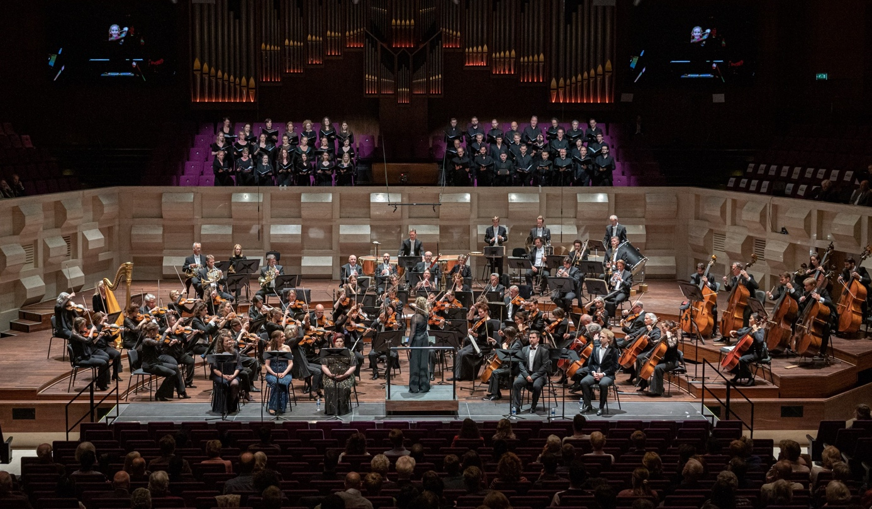
Rotterdam Philharmonic Orchestra, Laurens Symphonic Choir
Soloists: Claire Barnett Jones, Florieke Beelen, Anton Kuzenok, Kelly Poukens and Raoul Steffani.
Jury: Giordano Bellincampi, Jeremy Geffen, Ara Guzelimian (chair), Sophie de Lint, Enrique Mazzola, Kim Noltemy, Ed Spanjaard and Elmar Weingarten
Repertoire: Bizet - Carmen

Winner: Luis Toro Araya

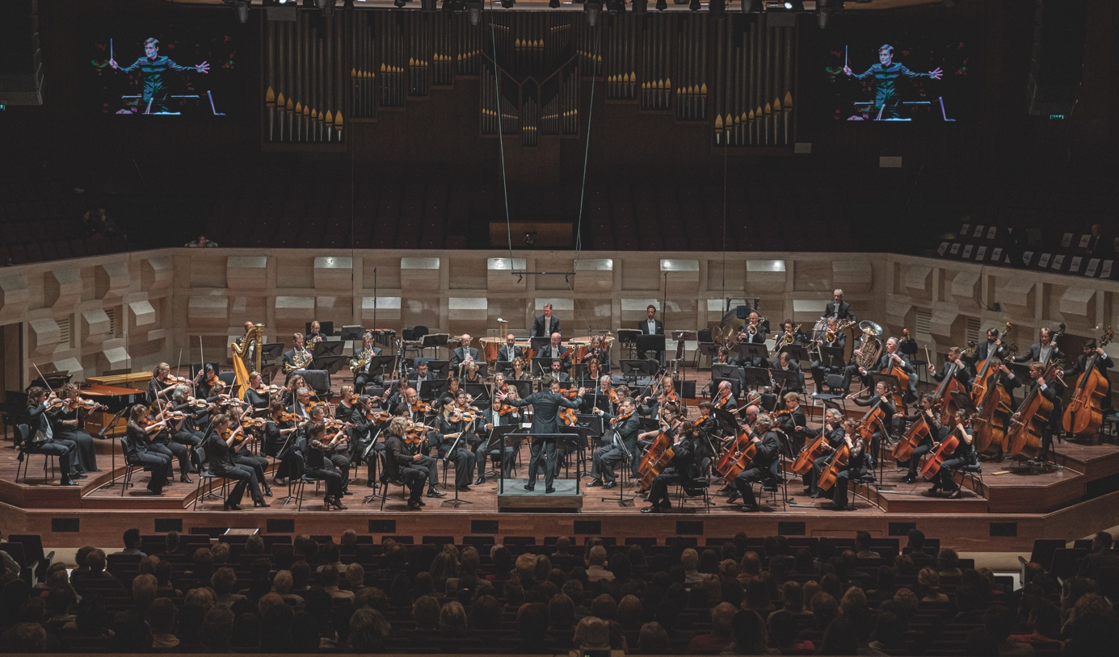
Symphonic round (2, 3 June)
Rotterdam Philharmonic Orchestra
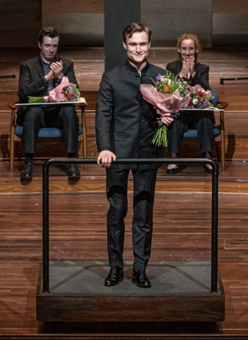
Jury: Jeremy Geffen, Ara Guzelimian (chair), Karina Canellakis, Lahav Shani, Ed Spanjaard, Shiyeon Sung, Maxim Vengerov and Elmar Weingarten.
Repertoire: Commissioned work by Joey Roukens. And Mahler, Tchaikovsky, Shostakovich

Winner: Bertie Baigent

Grand Prix: Bertie Baigent

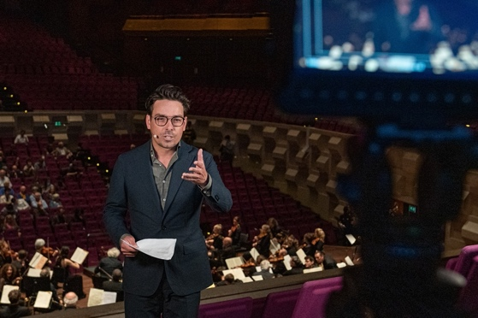
Webcast
All the rounds of the competition have been live streamed through version international partners: Medici TV (France) Takt1 (Germany), ViolinChannel (USA), Amadeus TV (China), NPO Radio4 (Netherlands), BBC Music (UK) and Only Conductors (Spain). In total over 4 million viewers were registrered.

Videocontent
During the year running up to the competition a stagering 105 videos were produced to promote the conductors. Including a documentary about each of the six conductorsAll can be found on the youtube page of ICCR: https://www.youtube.com/@conductingcompetitionrotterdam

